**Question 1: Do AgNPs have an effect on yellow perch N, P, C and Tag excretion?**

**Answer 1: AgNPs increase N excretion, decrease DOC excretion, and have no effect on P excretion.**

**Question 2: How does Tag release vary with time?**

**Answer 2: Tag release also decreases with time from the first year of AgNPs addition to the second**

# Log10 N, P, C excretion vs. log10 mass for all years by lake

* very bad relationships, may be due to the low variance in mass among individuals (from 0.4 to 8g for the entire dataset)

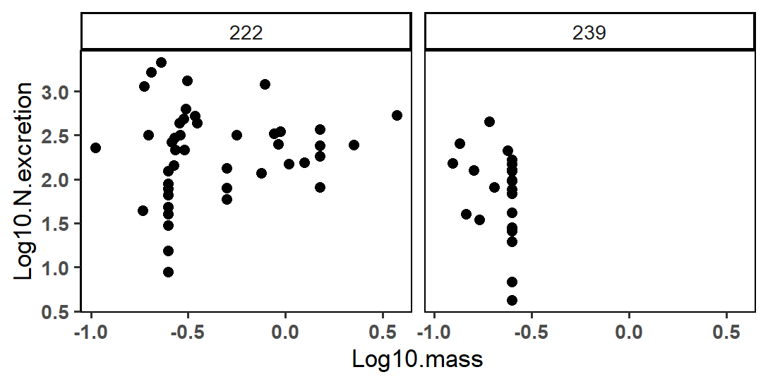

* Coeff of variation L222 = 0.17, coeff of variation L239 = -1.44

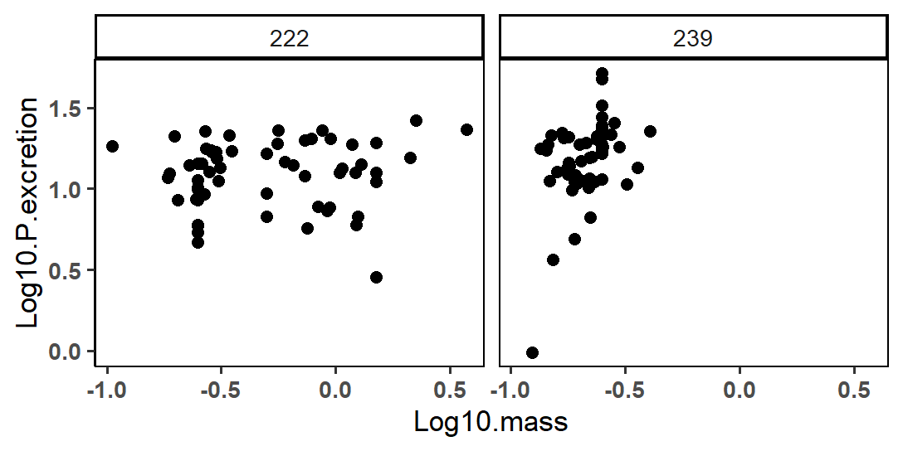

* Coeff of variation L222 = 0.05, coeff of variation L239 = 1.06

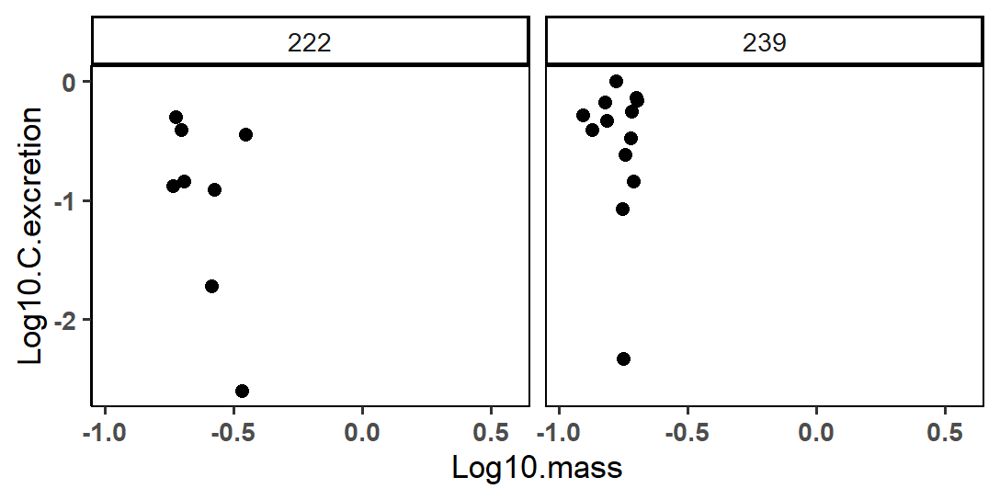

* Coeff of variation L222 = -3.54, coeff of variation L239 = -1.34

# Anova: Log TDN excretion in 2015 ~ Lake

* Excluding 2014 because of low sample sizes for both lakes; yet may be a difference between 2014/2015

summary(aov.Nnx)

Df Sum Sq Mean Sq F value Pr(>F)

Lake 1 8.087 8.087 9.158 0.00601 **

Residuals 23 20.311 0.883

---

Signif. codes: 0 ‘***’ 0.001 ‘**’ 0.01 ‘*’ 0.05 ‘.’ 0.1 ‘ ’ 1

25 observations deleted due to missingness

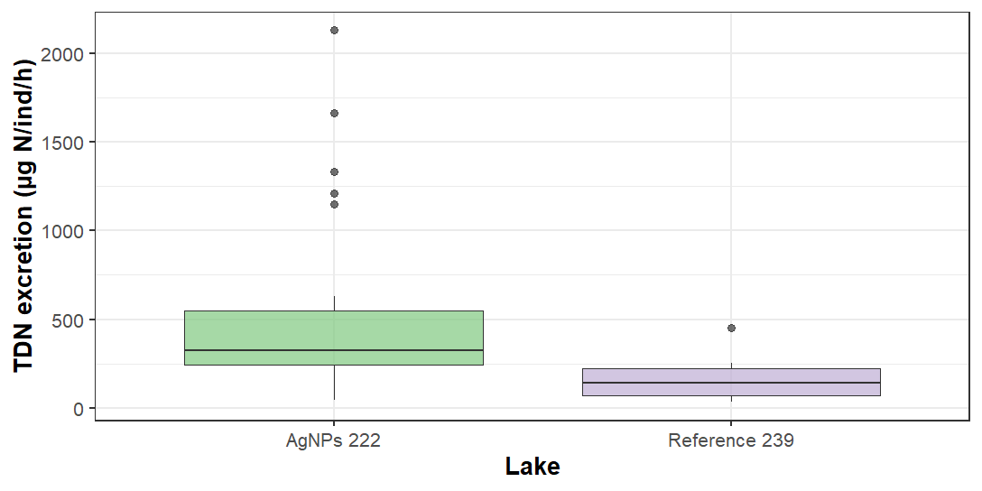

# Anova: TDN excretion in 2012, 2015 ~ Lake*Year

> summary(aov.Nx)

Df Sum Sq Mean Sq F value Pr(>F)

Lake 1 14.73 14.726 14.368 0.00037 ***

Year 1 23.61 23.605 23.032 1.22e-05 ***

Lake:Year 1 1.54 1.541 1.504 0.22519

Residuals 56 57.39 1.025

---

Signif. codes: 0 ‘***’ 0.001 ‘**’ 0.01 ‘*’ 0.05 ‘.’ 0.1 ‘ ’ 1

40 observations deleted due to missingness

# Linear model (no longer anova due to addition of factor “Mass”)using glm (x ~ y, family = Gamma (link = “log”)): TDN excretion in 2012, 2015 ~ Lake*Year*Mass

> summary(glm.Nx)

Call:

glm(formula = N.excretion ~ Lake * Year * Mass, family = Gamma(link = "log"),

data = NPexcr %>% filter(Year != "2014"))

Deviance Residuals:

Min 1Q Median 3Q Max

-1.9712 -0.7275 -0.1479 0.2892 1.5282

Coefficients: (1 not defined because of singularities)

Estimate Std. Error t value Pr(>|t|)

(Intercept) 3.9946 0.2421 16.503 < 2e-16 ***

Lake239 -1.3287 2.8245 -0.470 0.639994

Year2015 2.8079 0.8184 3.431 0.001173 **

Mass 0.7549 0.1927 3.918 0.000258 ***

Lake239:Year2015 -1.0768 1.0641 -1.012 0.316181

Lake239:Mass 5.8660 11.2387 0.522 0.603881

Year2015:Mass -2.3242 2.9393 -0.791 0.432624

Lake239:Year2015:Mass NA NA NA NA

---

Signif. codes: 0 ‘***’ 0.001 ‘**’ 0.01 ‘*’ 0.05 ‘.’ 0.1 ‘ ’ 1

(Dispersion parameter for Gamma family taken to be 0.5869308)

Null deviance: 89.459 on 59 degrees of freedom

Residual deviance: 38.365 on 53 degrees of freedom

(40 observations deleted due to missingness)

AIC: 745.09

Number of Fisher Scoring iterations: 7

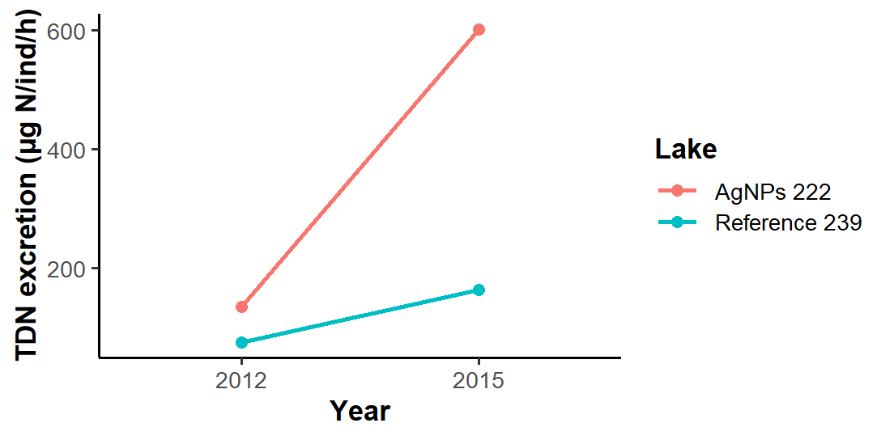

# Anova: TDP excretion ~ Lake

summary(aov.Pnx)

Df Sum Sq Mean Sq F value Pr(>F)

Lake 1 0.5 0.501 0.019 0.892

Residuals 76 2048.0 26.948

22 observations deleted due to missingness

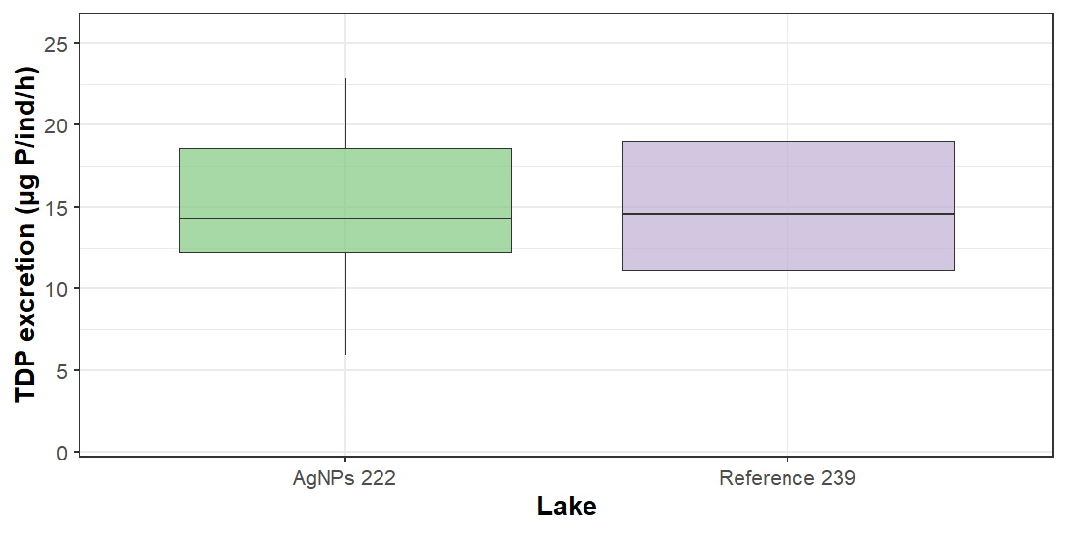

# Anova: Log TDP excretion in 2012, 2014, 2015 ~ Lake*Year

> summary(aov.Px)

Df Sum Sq Mean Sq F value Pr(>F)

Lake 1 1.698 1.6983 7.124 0.00875 **

Year 2 0.091 0.0455 0.191 0.82636

Lake:Year 2 5.954 2.9771 12.488 1.28e-05 ***

Residuals 111 26.462 0.2384

---

Signif. codes: 0 ‘***’ 0.001 ‘**’ 0.01 ‘*’ 0.05 ‘.’ 0.1 ‘ ’ 1

33 observations deleted due to missingness

> TukeyHSD(aov.Px, conf.level=0.95, which = 'Lake:Year')

Tukey multiple comparisons of means

95% family-wise confidence level

Fit: aov(formula = Log.P.excretion ~ Lake * Year, data = NPexcr)

$`Lake:Year`

diff lwr upr p adj

239:2012-222:2012 0.87065510 0.417019991 1.324290219 0.0000027

222:2014-222:2012 0.39519268 -0.058442436 0.848827792 0.1253372

239:2014-222:2012 0.41798614 -0.035648974 0.871621254 0.0891534

222:2015-222:2012 0.44286543 -0.004916087 0.890646938 0.0543826

239:2015-222:2012 0.27903753 -0.168743983 0.726819042 0.4653963

222:2014-239:2012 -0.47546243 -0.934876565 -0.016048289 0.0380140

239:2014-239:2012 -0.45266896 -0.912083102 0.006745174 0.0559330

222:2015-239:2012 -0.42778968 -0.881424793 0.025845435 0.0764578

239:2015-239:2012 -0.59161758 -1.045252689 -0.137982461 0.0033635

239:2014-222:2014 0.02279346 -0.436620676 0.482207601 0.9999912

222:2015-222:2014 0.04767275 -0.405962366 0.501307862 0.9996392

239:2015-222:2014 -0.11615515 -0.569790262 0.337479966 0.9760902

222:2015-239:2014 0.02487929 -0.428755828 0.478514399 0.9999855

239:2015-239:2014 -0.13894861 -0.592583725 0.314686503 0.9485917

239:2015-222:2015 -0.16382790 -0.611609409 0.283953616 0.8956187

# Anova using glm(x ~ y, family = Gamma (link = “log”)): TDP excretion in 2012, 2014, 2015 ~ Lake*Year

Call:

glm(formula = P.excretion ~ Lake * Year, family = Gamma(link = "log"),

data = NPexcr)

Deviance Residuals:

Min 1Q Median 3Q Max

-1.87588 -0.27159 -0.05697 0.23422 1.05090

Coefficients:

Estimate Std. Error t value Pr(>|t|)

(Intercept) 2.38377 0.09289 25.662 < 2e-16 ***

Lake239 0.78657 0.13308 5.910 3.82e-08 ***

Year2014 0.31352 0.13308 2.356 0.020236 *

Year2015 0.32861 0.13137 2.501 0.013828 *

Lake239:Year2014 -0.75594 0.18941 -3.991 0.000118 ***

Lake239:Year2015 -0.83771 0.18700 -4.480 1.82e-05 ***

---

Signif. codes: 0 ‘***’ 0.001 ‘**’ 0.01 ‘*’ 0.05 ‘.’ 0.1 ‘ ’ 1

(Dispersion parameter for Gamma family taken to be 0.1725741)

Null deviance: 28.650 on 116 degrees of freedom

Residual deviance: 22.144 on 111 degrees of freedom

(33 observations deleted due to missingness)

AIC: 769.74

Number of Fisher Scoring iterations: 5

# Linear model (no longer anova due to addition of factor “Mass”) using glm(x ~ y, family = Gamma (link = “log”)): TDP excretion in 2012, 2014, 2015 ~ Lake*Year*Mass

Call:

glm(formula = P.excretion ~ Lake * Year * Mass, family = Gamma(link = "log"),

data = NPexcr)

Deviance Residuals:

Min 1Q Median 3Q Max

-1.82557 -0.28410 -0.05445 0.26655 0.88945

Coefficients: (1 not defined because of singularities)

Estimate Std. Error t value Pr(>|t|)

(Intercept) 2.0467 0.1226 16.693 < 2e-16 ***

Lake239 0.6382 1.0229 0.624 0.53404

Year2014 0.8268 0.2856 2.895 0.00461 **

Year2015 0.5122 0.4124 1.242 0.21695

Mass 0.3241 0.0976 3.320 0.00123 **

Lake239:Year2014 -1.4882 1.1266 -1.321 0.18938

Lake239:Year2015 -0.9102 0.3572 -2.548 0.01226 *

Lake239:Mass 1.6176 4.0537 0.399 0.69067

Year2014:Mass -0.5093 0.2692 -1.891 0.06129 .

Year2015:Mass 0.2640 1.4818 0.178 0.85896

Lake239:Year2014:Mass 1.3202 4.3407 0.304 0.76160

Lake239:Year2015:Mass NA NA NA NA

---

Signif. codes: 0 ‘***’ 0.001 ‘**’ 0.01 ‘*’ 0.05 ‘.’ 0.1 ‘ ’ 1

(Dispersion parameter for Gamma family taken to be 0.1506051)

Null deviance: 28.650 on 116 degrees of freedom

Residual deviance: 19.547 on 106 degrees of freedom

(33 observations deleted due to missingness)

AIC: 764.71

Number of Fisher Scoring iterations: 5

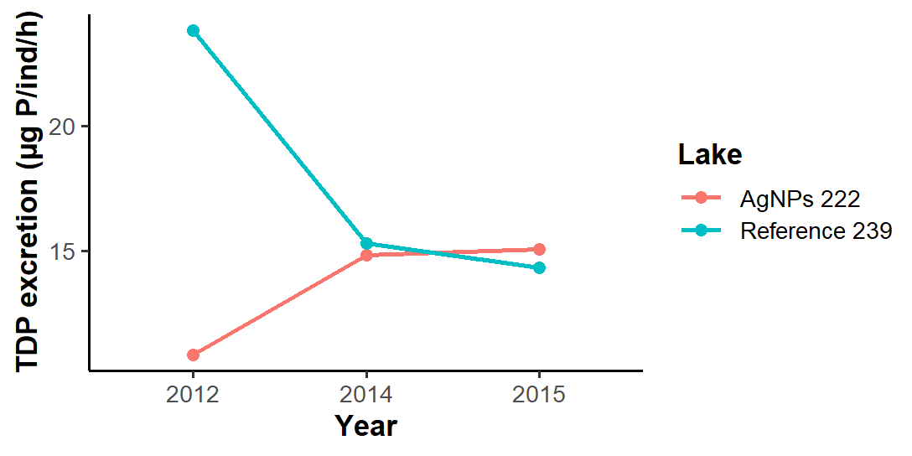

# Anova: DOC excretion ~ Lake

summary(aov.C)

Df Sum Sq Mean Sq F value Pr(>F)

Lake 1 0.2811 0.28111 4.41 0.0493 *

Residuals 19 1.2112 0.06375

---

Signif. codes: 0 ‘***’ 0.001 ‘**’ 0.01 ‘*’ 0.05 ‘.’ 0.1 ‘ ’ 1

79 observations deleted due to missingness

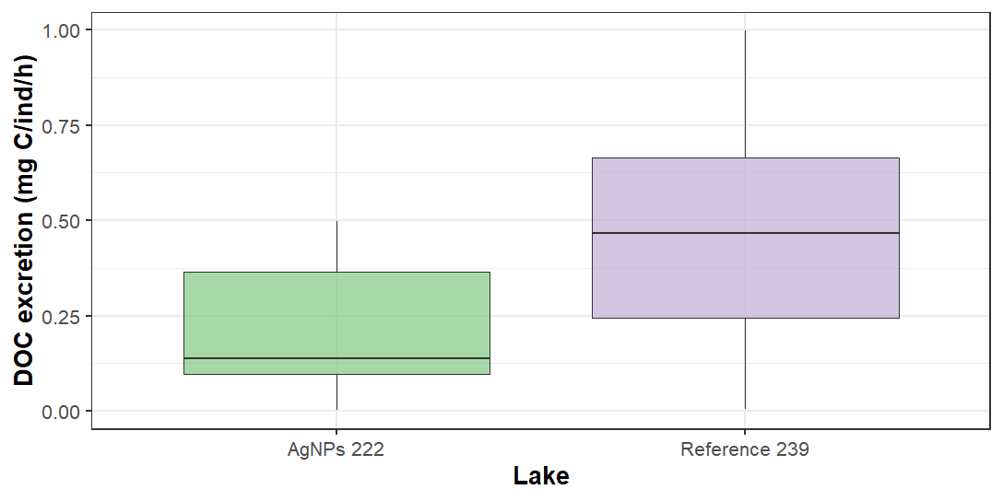

*Note: very low DOC excretion for both lakes*

# Excreted N:P ~ Lake*Year

> summary(aov.NPx)

Df Sum Sq Mean Sq F value Pr(>F)

Lake 1 15953 15953 2.579 0.11389

Year 1 69299 69299 11.205 0.00146 **

Lake:Year 1 262 262 0.042 0.83770

Residuals 56 346337 6185

---

Signif. codes: 0 ‘***’ 0.001 ‘**’ 0.01 ‘*’ 0.05 ‘.’ 0.1 ‘ ’ 1

40 observations deleted due to missingness

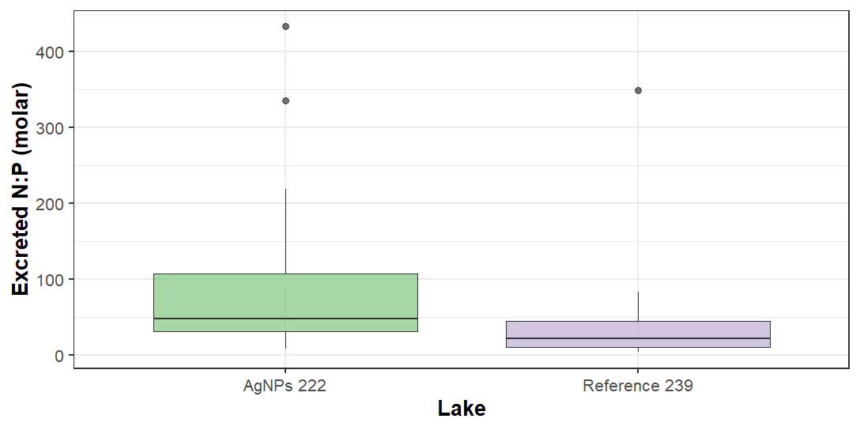

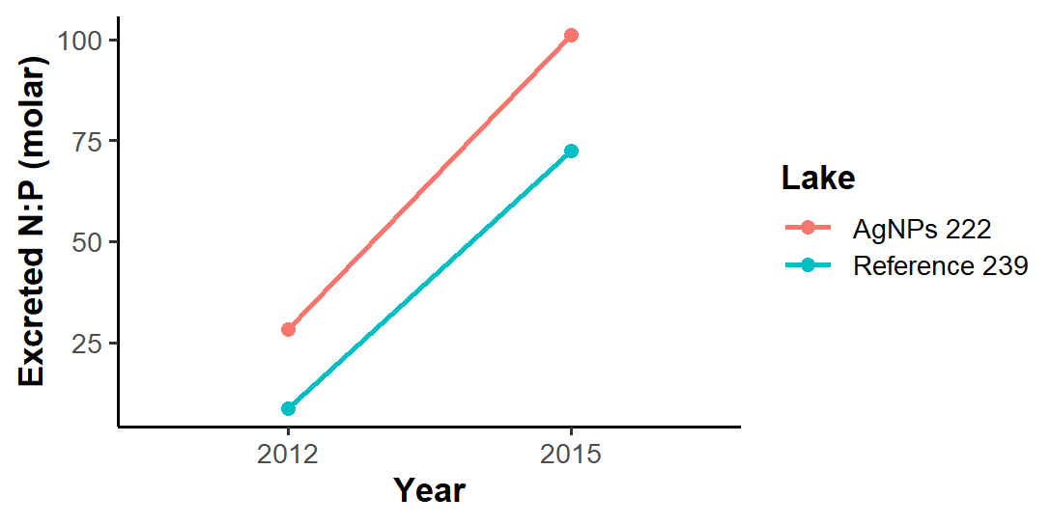

# Excreted C:N ~ Lake

> summary(aov.CN)

Df Sum Sq Mean Sq F value Pr(>F)

Lake 1 4.554 4.554 3.152 0.11

Residuals 9 13.004 1.445

139 observations deleted due to missingness

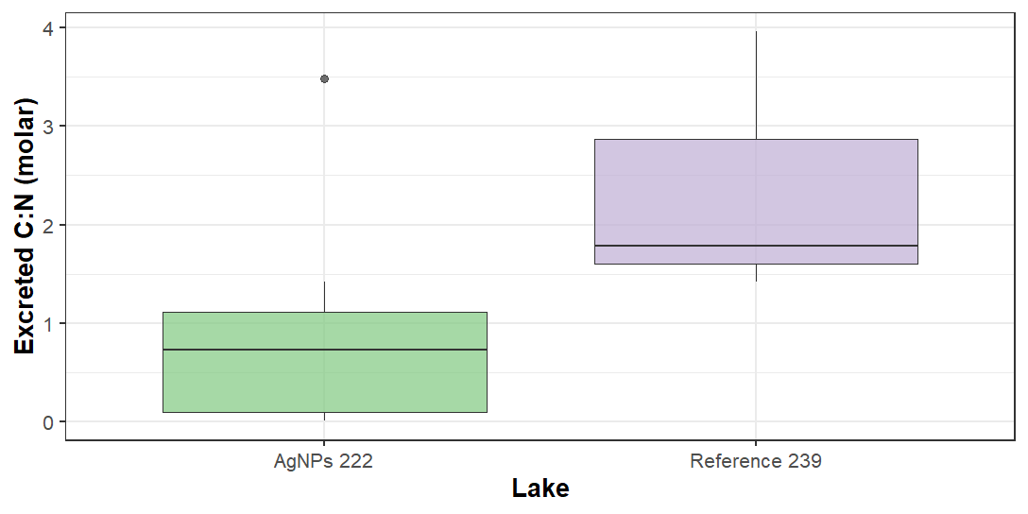

*Note: very low DOC excretion for both lakes + no time series because only have DOC data in 2015*

# Excreted C:P ~ Lake

# ..excreted C:P (molar) in 2015 ----

> aov.CP <- aov(Excreted.CP ~ Lake,

+ data = NPexcr)

> summary(aov.CP)

Df Sum Sq Mean Sq F value Pr(>F)

Lake 1 117838 117838 1.376 0.255

Residuals 19 1627291 85647

129 observations deleted due to missingness

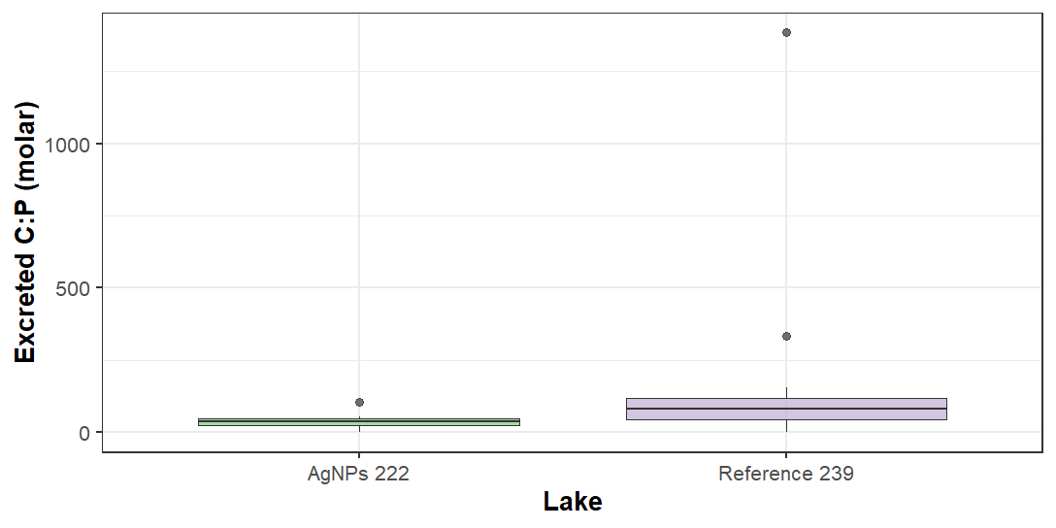

# Anova: Log Tag excretion ~ Year

summary(aov.Tag)

Df Sum Sq Mean Sq F value Pr(>F)

Year 1 5.48 5.480 13.5 0.00077 ***

Residuals 36 14.61 0.406

---

Signif. codes: 0 ‘***’ 0.001 ‘**’ 0.01 ‘*’ 0.05 ‘.’ 0.1 ‘ ’ 1

62 observations deleted due to missingness

# Linear model (no longer anova due to addition of factor “Mass”) using glm(x ~ y, family = Gamma (link = “log”)): TAg excretion in 2014, 2015 ~ Year*Mass

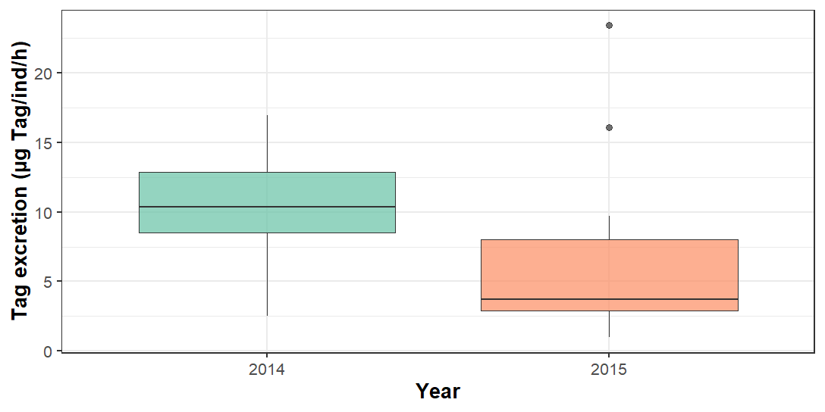

> summary(glm.Tagx)

Call:

glm(formula = Tag.excretion ~ Year * Mass, family = Gamma(link = "log"),

data = NPexcr)

Deviance Residuals:

Min 1Q Median 3Q Max

-1.3607 -0.4481 -0.1076 0.2222 1.7777

Coefficients:

Estimate Std. Error t value Pr(>|t|)

(Intercept) 2.4995 0.6661 3.753 0.000654 ***

Year2015 -0.2158 0.9849 -0.219 0.827837

Mass -0.1733 0.7174 -0.242 0.810609

Year2015:Mass -1.5857 2.7994 -0.566 0.574806

---

Signif. codes: 0 ‘***’ 0.001 ‘**’ 0.01 ‘*’ 0.05 ‘.’ 0.1 ‘ ’ 1

(Dispersion parameter for Gamma family taken to be 0.4972547)

Null deviance: 16.904 on 37 degrees of freedom

Residual deviance: 14.219 on 34 degrees of freedom

(112 observations deleted due to missingness)

AIC: 226.99

Number of Fisher Scoring iterations: 5